Constructions Unit Vocabulary PRE TEST
1. Which of the following triangles has angles with a measure less than 90°? CHOOSE ALL THAT APPLY
- Scalene
- Acute
- Right
- Isosceles
2. What does a bisector do? Choose all that apply.
- It divides an angle into two parts (not necessarily equal)
- It divides a line segment into two equal parts.
- It divides an angle into two equal parts.
- It multiplies the line or segment by a factor of two.
3. List the following polygons in order of LEAST sides to MOST sides. Choose all that apply.
- pentagons, heptagons, octagons, decagons
- heptagons, pentagons, hexagons, octagons
- square, pentagon, heptagon, nonagon
- pentagon, octagon, decagon, heptagon
4. A regular rectangle is a square.
a) True
b) False
5. An obtuse triangle also has acute angles in it?
- True
- False
6. Choose all that Apply: A triangle with interior degrees of 30° 60° 90° is a
- Scalene triangle
- Right triangle
- Obtuse triangle
- Impossible
7. Subtract the number of sides a pentagon has from the number of sides an octagon has. What do you get?
- 4
- 5
- 3
- 1
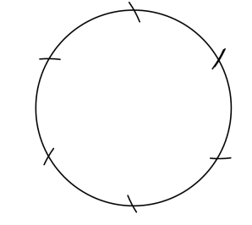
8. What length do you set your compass to to divide an arc in six equal lengths? Choose all that apply
a) the diameter
b) the radius
c) any length
d) 1 inch

9. CHOOSE ALL THAT APPLY An equilateral triangle…
- Has three sides of equal length
- Three angles of equal measure
- All 90° angles.
- Has a hypotenuse.
10. In relation to constructions, a straightedge is
a) a clear plastic device devoid of markings.
b) can be shaped like a triangle as long as it has a straightedge
c) used for drawing straight lines or segments, but not for measuring.
d) all of the above.
11. choose all that apply When you construct a perpendicular bisector, you are also constructing:
a) the midpoint
b) a right angle
c) a 90° angle
d) none of the above

12. When constructing the bisector of a line segment, you are also constructing the perpendicular bisector of the segment.
a) True
b) False

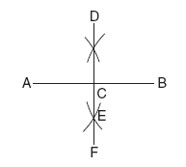
13. Which construction is shown in the accompanying diagram?
- The bisector of <ACD
- The midpoint of DF
- A perpendicular line to AB from D
- The perpendicular bisector of AB

