BellWork
EXAMPLE ANSWERS
a) Choose your favorite time of day. Write it down in numbers. 2:20

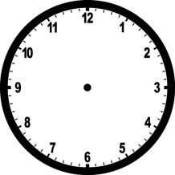
b) draw a clock showing that time

c) Write out how you would say that time Son las dos y veinte.

