1) The length of the radius

.

Observations:

Sinθ=

Cosθ=

Tanθ=

Cscθ=

Secθ=

Cotθ =

Sinθ=

Cosθ=

Tanθ=

Cscθ=

Secθ=

Cotθ =

$$Sinθ=\frac{y}{r}$$

$$Cosθ=\frac{x }{ r}$$

$$Tanθ=\frac{y}{x}$$

$$Cscθ=\frac{r}{y}$$

$$Secθ=\frac{r}{x}$$

$$Cotθ =\frac{x}{y}$$

**Trig Functions of Quadrantal Angles**

Sinθ=

Cosθ=

Tanθ=

Cscθ=

Secθ=

Cotθ =

Sinθ=

Cosθ=

Tanθ=

Cscθ=

Secθ=

Cotθ =

3) are undefined

on the x axis and

are undefined on the y axis.

2) The trig ratios on quadrantal angles

will always be either .

4) Will sine or cosine ever be undefined?

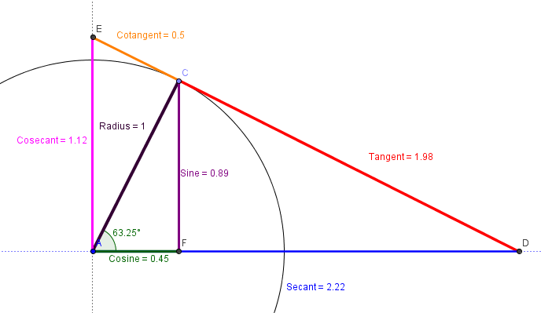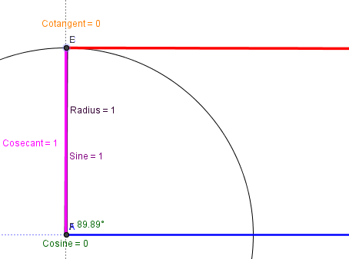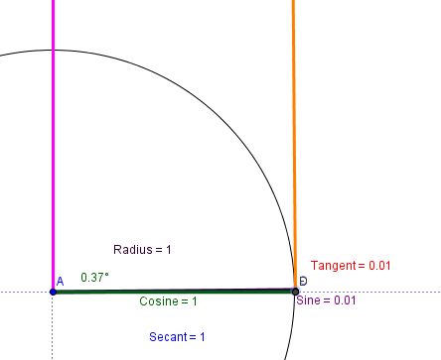

**90°**

**0°**