Project Overview
Name of Project: |  |  | Logo Construction Project |  |  |  |  |  |  |  |  |  | Duration: 1 Week
Subject/Course: GEOMETRY |  |  |  |  |  |  | Teacher: Gorsuch |  |  |  |  |  | Grade Level: 10-12
Other subject: |  |  | Design, Art, Reading, Math History, Technology
Project Idea  Summary of the issue, challenge, investigation, scenario, or problem: |  |  | The driving question for the unit is: “What’s hidden in design?” To answer the question students will explore the symbolism of numbers and basic constructions in this unit. They will be asked to complete a “booklet” of constructions (class work and homework) and also a small collaborative project at the end of the week. For the project each group will make up/ chose a company and create a sampling of logos (one per person) for that business.
Driving Question |  |  | What’s hidden in design?
Content and Skills Standards to be addressed: |  |  | G-CO.12. Make formal geometric constructions with a variety of tools and methods (compass and straightedge, string, reflective devices, paper folding, dynamic geometric software, etc.).  Copying a segment; copying an angle; bisecting a segment; bisecting an angle; constructing perpendicular lines, including the perpendicular bisector of a line segment; and constructing a line parallel to a given line through a point not on the line.  G-CO.13. Construct an equilateral triangle, a square, and a regular hexagon inscribed in a circle.  G-C-1 Justify steps of a construction and begin using deductive logic and flow charts (aka informal PROOFS)  SMP3 Construct viable arguments and critique the reasoning of others  SMP5 Use appropriate tools strategically  SMP8 Look for and express regularity in repeated reasoning
 |  |  |  |  |  |  |  | T+A | E |  |  |  |  |  |  | T+A | E
21st Century Skills  to be explicitly taught and assessed (T+A) or that will be encouraged (E) by project work, but not taught or assessed: |  |  | Collaboration |  |  |  |  | X |  |  | Creativity/ Innovation/ Engagement |  |  |  |  |  | X
 |  |  | Presentation |  |  |  |  | X |  |  | Writing |  |  |  |  | X
 |  |  | Critical Thinking: |  |  |  |  | X |  |  | Use of technology |  |  |  |  | X
 |  |  |  |  |  |  |  |  |  |  |  |  |  |  | Presentation Audience:
Culminating Products and Performances | Group: |  |  | Description of Company and Mission Statement  Collection of logos (one from each member) for the group’s company  Group presentation |  |  |  |  |  |  |  |  |  |  | Class: |  | X
Culminating Products and Performances |  |  |  |  |  |  |  |  |  |  |  |  |  |  | School: |  | X
Culminating Products and Performances |  |  |  |  |  |  |  |  |  |  |  |  |  |  | Community:
Culminating Products and Performances | Individual: |  |  | Vocab/ Construction Test  Construction Packet
Project Overview
Entry event to launch inquiry, engage students: |  | Geometric Logo/ Hidden Design Elements Anchor Video
Assessments |  | Formative Assessments  (During Project) |  |  | Exit Slips- daily |  |  |  |  | X |  | Practice Presentations- if time
 |  |  |  |  | Journal/Learning Log- construction packet |  |  |  |  | X |  | Notes- in construction packet |  |  |  |  |  | X
 |  |  |  |  | Preliminary Plans/ Prototypes- design sketch |  |  |  |  | X |  | Checklist- for final project |  |  |  |  |  | X
 |  |  |  |  | Rough Drafts- company information |  |  |  |  | x
 |  | Summative Assessments  (End of Project) |  |  | Written Product(s), with rubric:  Company description and logo justification |  |  |  |  | X |  | Other Product(s) or Performance(s), with rubric:  Logo designs/ Presentation |  |  |  |  |  | X
 |  |  |  |  | Oral Presentation, with rubric- group |  |  |  |  | X |  | Peer Evaluation- evaluate each member |  |  |  |  |  | X
 |  |  |  |  | End of unit Quiz |  |  |  |  | X |  | Self-Evaluation |  |  |  |  |  | X
.
Resources  Needed |  | On-site people, facilities: |  |  |  | Computer lab
 |  | Equipment: |  |  |  | Smart board, document camera (ELMO)
 |  | Materials: |  |  |  | Straightedge and compass per student, patty paper, paper
 |  | Community resources: |  |  |  | Internet resources
Reflection  Methods |  | (Individual, Group, and/or Whole Class) |  |  | Journal/Learning Log- construction packet |  |  |  |  | X |  | Focus Group- group members/ bell work groups |  |  |  |  |  | X
 |  |  |  |  | Whole-Class Discussion |  |  |  |  | X |  | Survey |  |  |  |  |  | X

Project Teaching and Learning Guide
Knowledge and Skills Needed by Students  to successfully complete culminating products and  performances, and do well on summative assessments |  |  | Scaffolding / Materials / Lessons to be Provided  by the project teacher, other teachers, experts,  mentors, community members
Number | Objectives | Symbolism | Constructions | Logo Examples | Assignment
ONE | -symbolism of 1  -compare drawing vs constructing  -use straightedge and compass (GCO12)  -justify steps | Wholeness, unity, integrity, origination of all shapes  Begins at a zero dimension (pt) surrounded by infinity  “Complexity around a single point is a common design for meditation. It reminds us of connection in the midst of chaos.”  Leader and confidence | Circle  Copy a line segment  Copy an angle | Target  Chanel  Audi | Copy line segment  Copy an angle  Add two segments  Subtract two segments  Add two angles
TWO | -define perpendicular, bisector, and equidistant  -use patty paper  -interpret the Perpendicular bisector conjecture  -shortest distance conjecture  -justify steps | Line both connects and divides.  Circle casting its reflection to distinguish self  Line- one dimension (length)  Opposites and duality  Opposition and conflict  Reciprocity (give and take)  Balance and partnership | Perpendicular bisector  Angle bisector | Mastercard  Nissan  Burger King  BMW | Construct perpendicular bisector  Divide a line into 4 equal parts  Construct an angle bisector  Construct a perpendicular line through a point not on the line  Draw obtuse angle and a point not on the angle. (shortest distance)
THREE | -construct equilateral triangle (GCO13  -test that the interior angles of a ) =180°  -classify triangles | Closure, plane, two dimensional, fire,  Transforming a base line into higher refinement.  Rmony, wisdom, understanding  Order, cycle, phases | Equilateral triangles  Right triangles  Inscribe triangle | Mitsubishi motors  Recycle symbol  MuSE logo (3) | Given a line seg, construct an isosceles right triangle with the given seg as the congruent sides  Draw a triangle. Then construct one with a perimeter half of that one.
FOUR | -classify quadrilaterals  -justify steps  -inscribe quadrilaterals  -construct parallel lines through a point (GCO12) | Depth, stability, and stillness  What we build our world with: think of buildings, sidewalks, windows, money,  Four sides anchor us into workable, tangible space, Strong, sturdy, Stability, order, justice  Steadfastness and security | Square  Rhombus  Parallel lines | H&R Block  Heart Hospital of New Mexico  Nintindo  Chase | Construct a rhombus  Construct a line parallel through a point
FIVE | -classify other polygons  -define regular  -justify steps | Animates life,  Represents life and love  Senses, five fingers, golden spiral which is said to be the most compelling proportion to humans,  Symbol of regenerated life, Marriage, health | Construct a pentagon  Inscribe a pentagon | STAR  Converse logo | Sketch 5 lines that intersect in exactly five points.  Copy a construction
SIX | -define arc length  -inscribe triangle, hexagon  -justify steps | Symbol of highly structured efficiency.  No waste/ high yield  Fits together without gaps  Often used in financially-related businesses to impart security and efficiency when handling your money, Beauty and high ideals | Inscribe a hexagon | Original Silicon Graphic  NBC | Copy a construction
Seven | -recognize in constructible numbers | VIRGIN number,  Number of chance and luck because of its illusive nature, Perfection, security, rest  All numbers except 7 divide evenly into 360°  7 is periodic (days of week, colors in rainbow)  Many goddesses were based on this number |  | Starbucks  rainbow

PROJECT CALENDAR
project: Logo Constructions |  |  | Start Date:
Day 1  One and Two | Day 2  Three and Six | Day 3  Four and Five |  | Day 4  Workday | Day 5  Workday/ Quiz
Objectives:  -symbolism of 1 and 2  -compare drawing vs constructing  -use straightedge and compass (GCO12)  -define perpendicular, bisector, and equidistant  -use patty paper  -justify steps  -shortest distance conjecture  Engage: Symbolism of 1 and 2 video  Explore Tasks:  -construct the symbol of unity  -Justify why two intersecting circles creates perpendicular lines  -Copy a segment  -Copy an angle  Explain  Watch constructions: line, angle, perpendicular bisector, angle bisector  Explain Logo Project  Elaborate  LOGO fun  Evaluate  Exit Slip:  Bisect an angle  Create a right angle  Assignment:  *Bring in a company and mission statement tomorrow  Copy line segment and copy an angle  Add two segments  Subtract two segments  Add two angles  Choose one to construct:  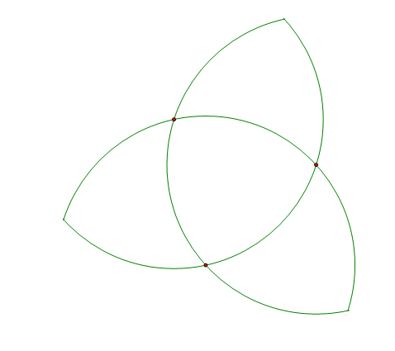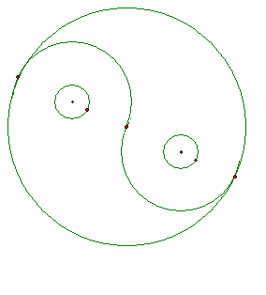  Materials:  Ruler, compass, video  SSR Math History Reading?  Logo Project Rubric  Homework worksheet | Objectives:  -symbolism of 3 and 6  -construct equilateral triangle  -test that the interior angles of a triangle=180°  -classify triangles  -define arc length  -inscribe triangle, hexagon  -justify steps  Engage  Symbolism of numbers 3 and 6  Explore  Divide the outside of the circle into six equal sections  Match the definitions of six equilateral triangles to create a hexagon  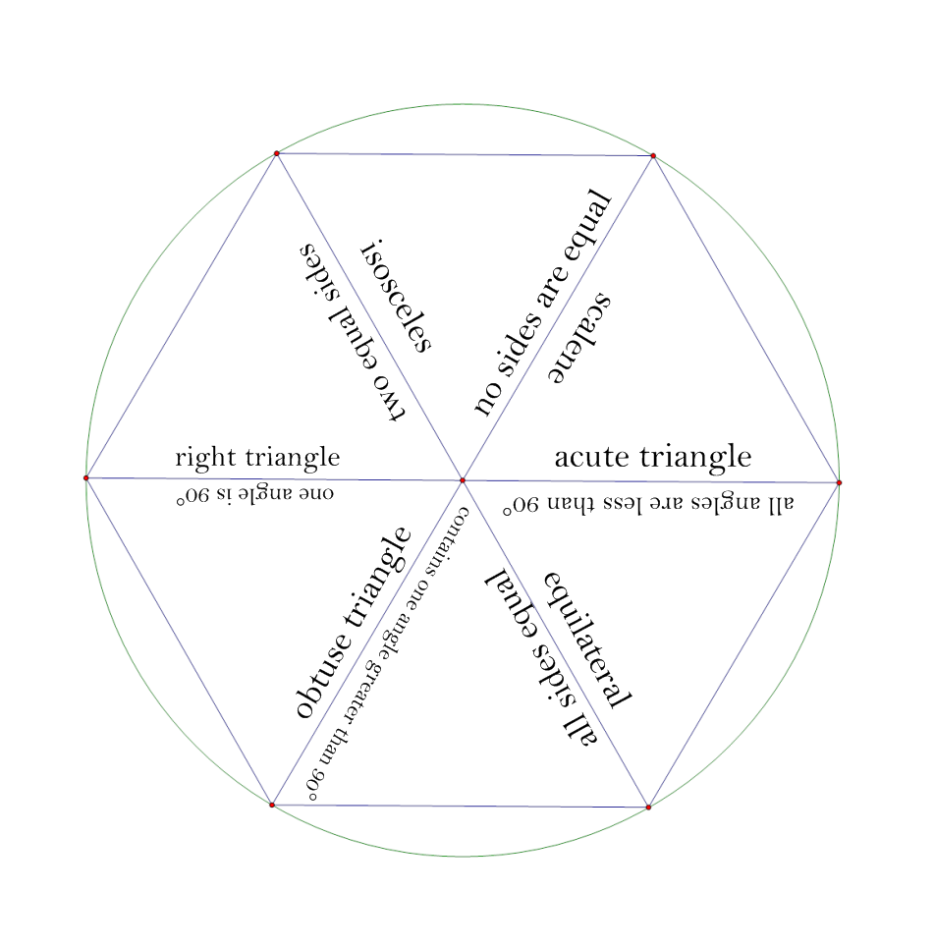  Use a protractor to measure the interior angles of 3 different triangles.  Explain  Regular hexagons are equal to six equilateral triangles  -swing the radius around the circumference to divide into 6 sections  Watch Construction: Equilateral triangle  Elaborate  Logo Product- Have students pick a company/ mission statement  Brainstorm designs you like  Evaluate  Exit Slip:  Given justifications for a proof, decide which triangle was constructed  Find the missing angle in a triangle.  Assignments  Given a line segment, construct an isosceles right triangle with the given segment as the congruent sides  Draw a triangle. Then construct one with a perimeter half of that one.  Construct an obtuse angle and then copy it.  Pick 2 designs to copy (give choices)  Materials:  Triangle matching activity (1 per group)  Handout with three triangles  protractors  SSR Math History Reading?  Homework worksheet | Objectives:  -classify quadrilaterals  -justify steps  -inscribe quadrilaterals  -construct parallel lines through a point  -classify other polygons  -define regular  -justify steps  Engage  Symbolism of numbers 4 and 5  Explore  Patty paper exploration of different quadrilaterals.  Explain  Constructions (and definitions) of square and parallelogram.  (also parallel lines)  Explore again  Cool Sketch Video of changing shapes.  Explain Again  Discuss names of polygons  Define regular  Elaborate  Logos- pick a unifying theme for logo and sketch rough drafts of individual logos  Evaluate  Exit Slip:  What do you call a 7 sided polygon?  What is a regular rectangle called?  Construct a parallelogram.  DUE: Company mission statement and description.  Assignment:  *Create a preliminary sketch for logo  Construct a rhombus  Construct a line parallel through a point  Sketch 5 lines that intersect in exactly five points.  Choose 2 designs to copy  Materials  Sketch Video  SSR Math History Reading?  Patty paper  Homework worksheet |  | Objectives:  -recognize non-constructible numbers  Engage  Seven Video and Show example final projects  Rest of Class  Share Sketches and practice presentation.  Review for Quiz (by looking over constructions packet)  Work on final sketches  Give students checklist for the day/ project  DUE:  Constructions HW Packet (but not really- show teacher- get feedback)- Reassign (with revisions) for next class  Assignment  Take home quiz due two days later  Remind: In class vocab quiz tomorrow and Final Presentations!  Final Constructions Packet | Objectives:  VOCAB/ Written in class QUIZ  DUE:  Presentations  Construction Packet  Due Next Day:  Take home test (with peer evaluations on it)

Reference Materials
Logos: http://www.logoguru.co.uk/blog/famous-logos-with-simple-shapes/
Design and Logos- Decoding Design http://www.decodingdesign.com/images/DecodingDesign_overview.pdf
Symbols and their Meaning http://www.crossroad.to/Books/symbols1.html
Changing Logos over time http://prasannah.posterous.com/how-10-famous-logos-have-changed-over-time
Peer Evaluation http://www.pbs.org/now/classroom/peer2.pdf
Creative Constructions Workbook (Seymour and Schadler)

