Constructions Unit Vocabulary Test
1. Which of the following triangles has angles with a measure less than 90°?
- Scalene
- Acute
- Right
- Isosceles
2. What does a bisector do? Choose all that apply.
- It divides an angle into two parts (not necessarily equal)
- It divides a line segment into two equal parts.
- It divides an angle into two equal parts.
- It multiplies the line or segment by a factor of two.
3. List the following polygons in order of LEAST sides to MOST sides. Choose all that apply.
- pentagons, heptagons, octagons, decagons
- heptagons, pentagons, hexagons, octagons
- square, pentagon, heptagon, nonagon
- pentagon, octagon, decagon, heptagon
4. A regular rectangle is a square.
a) True
b) False
5. True/ False. An obtuse triangle also has acute angles in it?
- True
- False
6. Choose all that Apply: A triangle with interior degrees of 30° 60° 90° is a
- Scalene triangle
- Right triangle
- Obtuse triangle
- Impossible
7. Subtract the number of sides a pentagon has from the number of sides an octagon has. What do you get?
- 4
- 5
- 3
- 1
8. True or False? The shortest distance from a point to a line is through the perpendicular bisector.
- True
- False
9. An equilateral triangle
- Has three sides of equal length
- Three angles of equal measure
- All 90° angles.
- Has a hypotenuse.
10. In relation to constructions, a straightedge is
a) a clear plastic device devoid of markings.
b) often shaped like a triangle.
c) used for drawing straight lines or segments, but not for measuring.
d) all of the above.
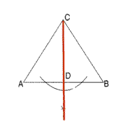
11. According to the construction shown in the diagram below, what do we call segment?
- Bisector of angle C
- Median to side
- perpendicular bisector of segment
- altitude to side

12. When constructing the bisector of a line segment, you are also constructing the perpendicular bisector of the segment.
a) True
b) False

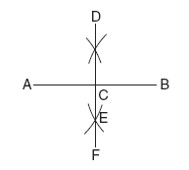
13. Which construction is shown in the accompanying diagram?
- The bisector of <ACD
- The midpoint of DF
- A perpendicular line to AB from D
- The perpendicular bisector of AB

