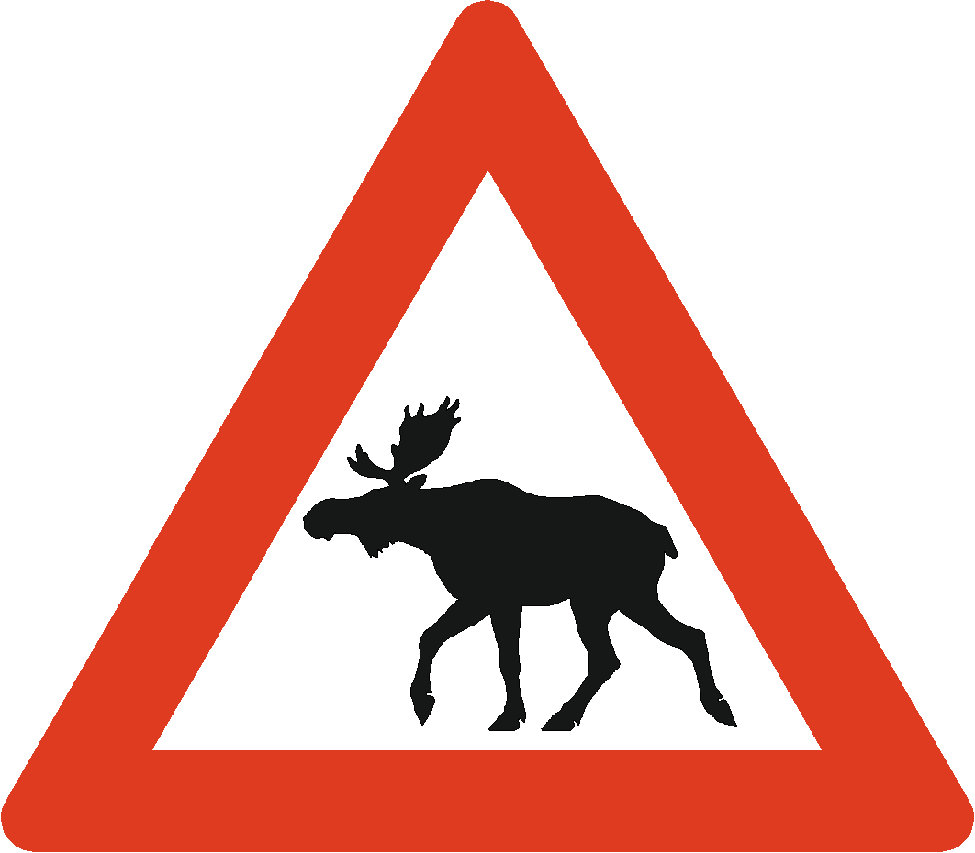
The moose warning sign at the left is an equilateral triangle. The height of the sign is 1m. Find the length s of each side of the sign to the nearest tenth of a meter.
Hint: The triangle is equilateral, so the altitude divides the triangle into two 30°-60°-90° triangles.
A. On #1, how do you prove/ show that the hypotenuse of a 30-60-90 triangle is 2s?
B.

The moose warning sign at the left is an equilateral triangle. The height of the sign is 1m. Find the length s of each side of the sign to the nearest tenth of a meter.
Hint: The triangle is equilateral, so the altitude divides the triangle into two 30°-60°-90° triangles.
A. On #1, how do you prove/ show that the hypotenuse of a 30-60-90 triangle is 2s?
B.

The moose warning sign at the left is an equilateral triangle. The height of the sign is 1m. Find the length s of each side of the sign to the nearest tenth of a meter.
Hint: The triangle is equilateral, so the altitude divides the triangle into two 30°-60°-90° triangles.
A. On #1, how do you prove/ show that the hypotenuse of a 30-60-90 triangle is 2s?
B.

Check your Answer:
Side= 1.155m (approximate answer)

Check your Answer:
Side= 1.155m (approximate answer)

Check your Answer:
Side= 1.155m (approximate answer)

