PART 1
1) In SketchPad, grab point B and drag it around the circle. Notice how the signs of the six trig functions change? In the four quadrants below list the functions that are positive. (See quadrant II as an example).
Sin
Csc

2) Determine the signs of the 6 trig functions for
a) θ=-200° b) θ= 300°

3) Identify the quadrant of θ if θ satisfies the given conditions:
a) sinΘ > 0 and tan Θ <0 b) cos Θ > 0 and secΘ<0

PART 2
Use the 6-function Unit Circle and the Pythagorean Theorem to discover the Pythagorean Identities.
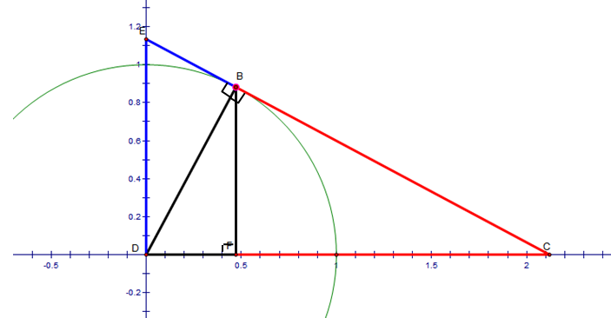
4) Label the segments on the graph with the 6 trig functions.
5) Look for the three right triangles and apply the Pythagorean Theorem to their sides.
List those relationships here:
EX: $\sin^{2}θ{+\cos^{2}θ{=1^{2}}}$

